GOAL:
The Speaking Up Advocacy Group is to support participants in self-advocacy:  While most who attend are from Day Activities groups, the Speaking Up Advocacy Group is open to anyone using Kyeema supports. | 

OBJECTIVES:

The objectives of the Advocacy Group are to:

- Identify areas for improvement  - Voice a new idea  - Bring up issues people may have  - Share information with each other  - Listen to each other  - Share upcoming events | 

TASKS:

- Run the meetings  - Receive reports from OH&S Representatives and from representatives who attended the regional All Abilities Advocacy Group. | 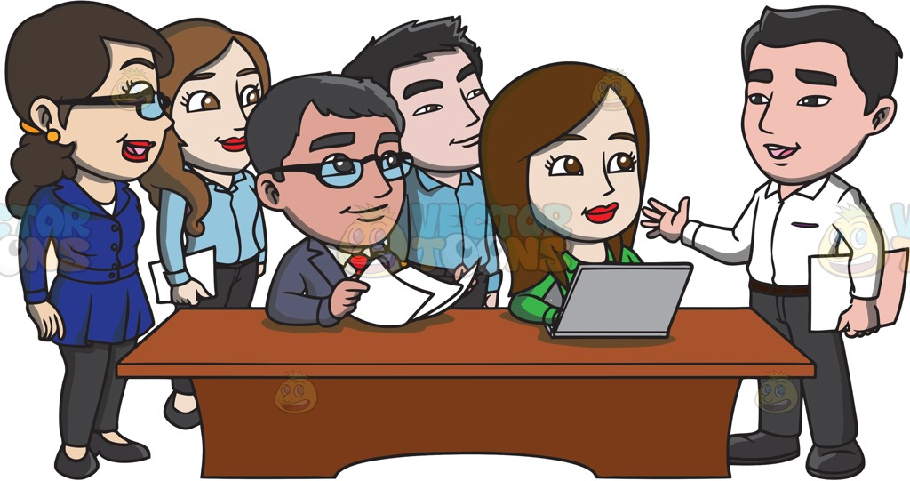

Membership of the Speaking Up Advocacy Group:
Community Advocate
Iain McDonald

Kyeema
Participants
Community Advocate
Sue Miller

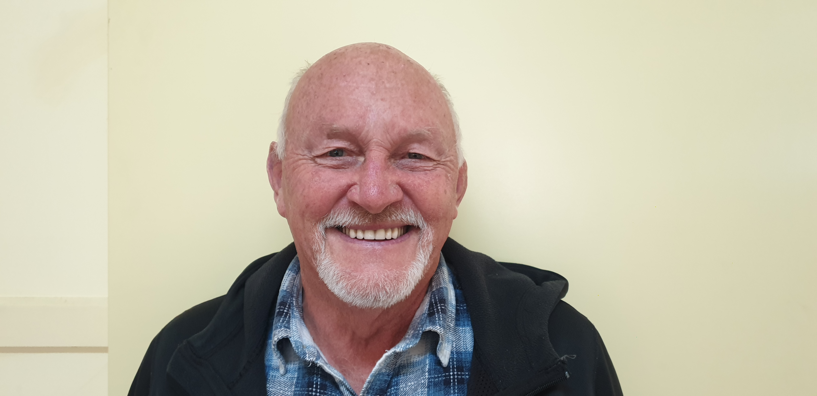

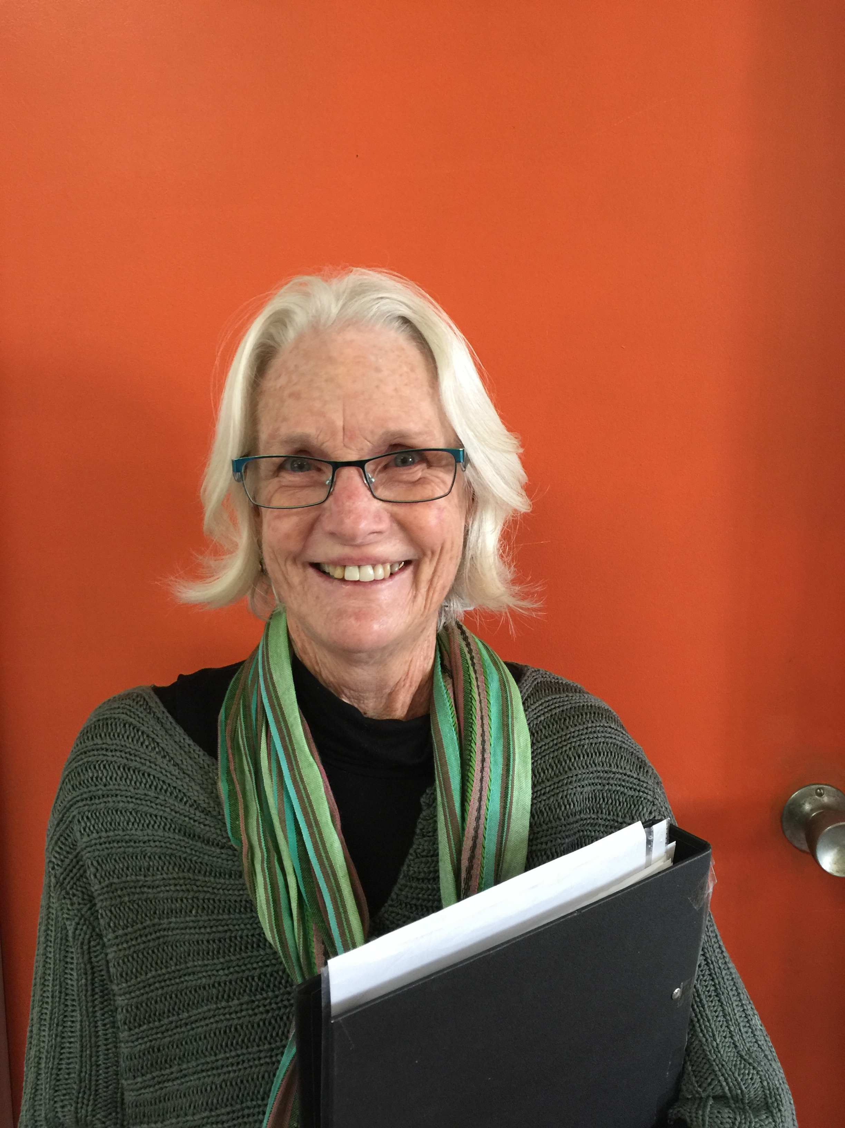

number of people required at meetings:
There is no minimum number of people to run a meeting. | 
- Meetings will be held weekly and usually go for 20 minutes
- Notes from each meeting are to be read at the following meeting to all attending.

